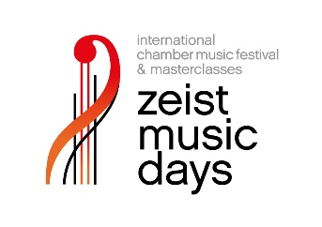
Registration form for the Zeist Music Days Masterclasses
All ensemble members must register individually.

Full name

M/F

Date of birth (dd/mm/yyyy)

Nationality

Address

Town & postal code

Country

Phone number

Email address

Musical instrument

Student at

Graduate of

Name of ensemble

Date:
Name:

Email the form, a recent recording of two works - including one classical piece - and your personal as well as your ensemble CV by May 31, 2023 to students@zeistmusicdays.nl

Name of music academy
Name of music academy

