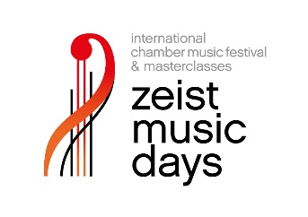
Registration form for the Zeist Music Days Masterclasses
All ensemble members must register individually.

Full name
M/F
Date of birth (dd/mm/yyyy)
Nationality
Address
Town & postal code
Country
Phone number
Email address
Musical instrument
Student at
Graduate of
Name of ensemble

Date:
Name:

Email the form, a recent recording of two works - including one classical piece - and your personal as well as your ensemble CV by May 31, 2025 to students@zeistmusicdays.nl

